Basket Ball Shot Prediction
Group Members:
Jayesh Kumar Chavvakula | - | AP23110020124
Roopanadh Sure | - | AP23110020062
Surya Venkata Raviteja Godavarthi | - | AP23110020054

Abstract:
This project aims to leverage computer vision and machine learning techniques to predict the outcome of a basketball shot before it reaches the hoop. Using video input, the system tracks the basketball’s trajectory in real time by detecting its position frame by frame through color segmentation and contour detection using Open CV and the CV-Zone library.
With the gathered coordinates, a second-degree Polynomial Regression model is applied to fit a parabolic curve that represents the ball's flight path. By analyzing this curve and computing where it intersects the hoop’s y-coordinate, the model predicts whether the shot will result in a basket or a miss.
The core strength of this project lies in its visual feedback. Each frame overlays the trajectory prediction, and the system displays the prediction result (“Basket” or “No Basket”) on-screen with dynamic text rendering. This real-time interactivity demonstrates a practical implementation of regression techniques in sports analytics.
The project is simple to deploy, yet impactful, showcasing the practical potential of machine learning in enhancing sports performance analysis. It also serves as a gateway for deeper predictive modeling in sports, using lightweight and accessible tools.

Existing System
In the Existing System, basketball shot prediction typically involves manual or basic video analysis. Coaches, analysts, or software use basic visual inspection or simpler algorithms to analyze the trajectory of a basketball shot.
Some existing systems rely on traditional computer vision techniques, but they often lack real-time interaction and accurate prediction of the shot outcome.

Manual Analysis or Basic Motion Detection-
- Existing systems often rely on simple motion tracking or human-based analysis to predict the success of a shot.
- These systems might use basic frame-by-frame analysis, but they don't provide detailed or accurate predictions of the ball’s flight path.
Limitations of Existing Systems-
- Accuracy: Most existing methods are not precise enough to predict shot outcomes accurately, especially in real-time.
- Speed: Manual or traditional methods can be slow and cumbersome for high-speed analysis.
- Lack of Advanced Modeling: Many systems do not use advanced machine learning or regression models to analyze the ball’s trajectory, leading to less accurate predictions.
- Real-time Feedback: Most systems fail to provide immediate feedback during the game or training, limiting their usefulness in dynamic, real-time environments.
Proposed system:
The Proposed System introduces a real-time solution using a computer vision and machine learning techniques to predict basketball shot outcomes with greater accuracy and interactivity.
  - Key Features of the Proposed System-
- Real-Time Video Analysis: The system processes video frames in real-time to track the basketball's position through color segmentation and contour detection.
- Trajectory Prediction: By applying a second-degree Polynomial Regression model, the system fits a parabolic curve to predict the flight path of the ball.
- Outcome Prediction: The system predicts whether the ball will go into the hoop (“Basket”) or miss the hoop (“No Basket”) by calculating where the ball’s predicted trajectory intersects the hoop’s y-coordinate.
- Visual Feedback: The system overlays the predicted trajectory on the video, providing dynamic text feedback in real-time on whether the shot is predicted to be a success or a miss.

  - Advantages of the Proposed System-
- Accuracy and Precision: The use of regression modeling and real-time tracking ensures a high level of accuracy in predicting the outcome of a shot.
- Real-Time Feedback: Provides immediate visual and text feedback during practice or games, enhancing player and coach engagement.
- Scalability: The system can be deployed in different sports settings with minimal setup, allowing for large-scale performance analysis.
- Machine Learning Integration: The use of machine learning techniques allows the system to improve over time as it processes more shots, making it adaptable to different shooting styles and conditions.
  - Real-Time Interactivity-
The system’s ability to display the prediction instantly during game-play offers an innovative tool for coaches and players to analyze shot mechanics and improve performance in real-time.
Feature | Existing Model | Developed Model (Proposed)
Ball Detection | Basic HSV masking | Tuned HSV + CVZone contours for accurate detection
Prediction Technique | Polynomial Regression | Polynomial Regression (same model, optimized performance
Trajectory Visualization | No trajectory or minimal line drawing | Real-time ball tracking with dynamic trajectory lines
Prediction Display | Only final "Basket" / "No Basket" | Live result display mid-trajectory with cv zone.
Metrics Graph | Not Available | Live-updating matplotlib plot for X-Y ball trajectory
User Interface | Console output / static visuals | Real-time video with visual overlays + graph window
Interactivity | None | Fully interactive with user-friendly visuals
Presentation  Readiness | Not suitable for UI demonstration | Suitable for project fair, demos, and academic presentation
Web Integration | Not available | Web showcase with thematic basketball
Future Scope Mentioned | Not defined | KNN version and enhanced analytics planned
Theory:
The project leverages the fields of Computer Vision (CV) and Machine Learning (ML) to predict the outcome of a basketball shot before it reaches the hoop. Computer Vision enables machines to interpret and understand the visual world, allowing the system to process and analyze video data to track the basketball’s position. In this project, video input is used to track the ball’s trajectory frame by frame, using color segmentation and contour detection techniques to isolate the ball from the background and capture its movement. Machine Learning, on the other hand, provides the ability to create predictive models based on data. In this case, a second-degree Polynomial Regression model is employed to model the parabolic path of the ball, predict its future trajectory, and determine whether it will successfully make it into the hoop.
The development environment for this project was PyCharm, a popular integrated development environment (IDE) for Python programming. PyCharm is ideal for building machine learning and computer vision projects due to its seamless integration with libraries like OpenCV, CVZone, and NumPy. These libraries provide the necessary tools to handle video processing, computer vision tasks, and mathematical computations. PyCharm's features, such as code completion, debugging tools, and real-time output visualization, made it an excellent choice for developing, testing, and fine-tuning the system.
To track the basketball, the project employs color segmentation, a fundamental computer vision technique where the color of the basketball is isolated from the surrounding background. By detecting the ball's specific color range in the video frames, the system can focus on the ball while disregarding other elements in the scene. Once the ball is identified, contour detection is used to locate the boundary of the ball in the frame. OpenCV provides powerful functions like findContours(), which help track the position of the ball as it moves through each frame. By continuously gathering these coordinates, the system can build a model of the ball’s flight path.
To predict the shot outcome, the system uses Polynomial Regression, specifically a second-degree (quadratic) polynomial, to fit a curve to the tracked trajectory data. This regression model calculates a mathematical equation that describes the ball’s parabolic path, which is critical for predicting where the ball will land. Polynomial regression is a form of regression analysis that allows for nonlinear relationships between variables—in this case, the ball’s horizontal and vertical positions in each frame. The fitted equation is then used to predict where the ball will be at any given point, and specifically, whether it will intersect the hoop’s height. If the trajectory intersects the hoop’s position, the system predicts a “Basket”; otherwise, it predicts a “No Basket.”
An exciting feature of the proposed system is its real-time feedback capability. As the system processes the video frames, it overlays the predicted trajectory of the ball on the live video feed and displays a prediction result on the screen (either “Basket” or “No Basket”). This real-time interaction provides valuable insights for coaches and players, enabling them to evaluate shot accuracy instantly and adjust their techniques as needed.
The project makes extensive use of several Python libraries, each playing a critical role in ensuring the system functions as intended. OpenCV is utilized for core computer vision tasks such as color segmentation and contour detection. It offers a range of functions that make it easier to track objects in video frames. CVZone, a higher-level Python library built on OpenCV, is used to simplify object tracking and analysis. It allows for easy integration of advanced computer vision techniques, which is particularly useful when working with dynamic video data. NumPy, another key library, is used for handling numerical data, including the arrays of coordinates that track the ball’s position and the matrix operations needed for fitting the regression model.
By combining computer vision and machine learning techniques, this project demonstrates the potential of real-time sports analytics. It showcases how technology can assist in improving performance by providing immediate feedback on shot accuracy. The system's simplicity in deployment and accessibility, owing to the use of Python and popular libraries, makes it an effective tool for training and performance analysis in basketball. In the future, this approach could be expanded to include more sophisticated predictive models, such as deep learning algorithms, which could account for additional factors like player movement, ball spin, and environmental conditions, offering even more accurate predictions.
Algorithm:
Step 1: Initialize Libraries and Variables
- Import necessary libraries:
  - math, cv2, cvzone, numpy, and matplotlib.pyplot.
- Initialize the video capture:
  - Open the video file to process each frame.
- Set up the color detection object:
  - Define HSV color values to filter the ball's color (using ColorFinder).
- Set up lists to store ball positions:
  - posListX for X-coordinates and posListY for Y-coordinates.
  - Predefine xList to create the quadratic regression plot.
- Initialize plot for visualizing the ball’s trajectory:
  - Set up a live plotting window with axes, title, labels, and initial empty data points.
Step 2: Process Video Frames
- Loop through each frame of the video:
  - Read the frame using cap.read(). If no frame is found, exit the loop.
- Crop the image (optional for faster processing):
  - Crop the image to focus on the region of interest (e.g., the court area).
- Color-based detection of the ball:
  - Use myColorFinder.update() to apply the color filter and find the ball's position.
  - Generate a mask and find contours using cvzone.findContours().
- Track ball position:
  - If contours are found, extract the center position of the ball and add the X and Y coordinates to posListX and posListY.
Step 3: Fit Quadratic Curve for Trajectory
- If ball positions are available (i.e., at least 1 position):
  - Use np.polyfit() to fit a quadratic equation to the ball's tracked positions.
- Plot the trajectory on the frame:
  - Plot the ball's past positions as circles and connect them with lines.
  - Use the fitted quadratic equation to predict future positions of the ball and draw these predicted points on the frame.
Step 4: Basket Prediction
- Predict the ball's path:
  - For the first few positions (less than 10 data points), calculate the quadratic equation of the ball's trajectory.
- Check if the ball reaches the target range (the basket area):
  - Use the quadratic formula to predict the X-position at the point where the ball will hit the ground (Y = 0).
  - If the X-position falls within a predefined target area (e.g., 330 < X < 430), set the prediction flag to True.
- Display the prediction:
  - If prediction is True, display the message "Basket" on the frame in green.
  - Otherwise, display "No Basket" in red.
Step 5: Update Plot and Display
- Update the live plot:
  - Update the plot with the new ball positions and the quadratic regression line.
- Resize and display the processed frame:
  - Resize the frame for better viewing.
  - Show the frame with the trajectory and prediction message.
- Exit condition:
  - If the user presses the 'q' key, break the loop and release the video capture.
Step 6: Cleanup
- Release video capture:
  - Release the video capture object to free up resources.
- Close all OpenCV windows:
  - Close the display windows used for showing frames.
Flow Chart:
Start
↓
Initialize Libraries & Variables
↓
Open Video File (cap = cv2.VideoCapture)
↓
Read Video Frame
↓
Is Frame Valid?
↓
Yes → Crop Frame
↓
Detect Ball Using Color Filtering
↓
Track Ball Position (Update posListX & posListY)
↓
Are Ball Positions Available?
↓
Yes → Fit Quadratic Curve (np.polyfit)
↓
Update Trajectory Plot
↓
Predict Ball Basket (Using Quadratic Formula)
↓
Display 'Basket' or 'No Basket'
↓
Show Processed Frame with Trajectory & Prediction
↓
Check for 'q' Key Press (Exit Condition)
↓
Yes → Cleanup & Release Resources
↓
END
No → End Process

Program:
import math
import cv2
import cvzone
from cvzone.ColorModule import ColorFinder
import numpy as np
import matplotlib.pyplot as plt

# Initialize the Video
cap = cv2.VideoCapture('Videos/vid (4).mp4')

# Create the color Finder object
myColorFinder = ColorFinder(False)
hsvVals = {'hmin': 8, 'smin': 96, 'vmin': 115, 'hmax': 14, 'smax': 255, 'vmax': 255}

# Variables
posListX, posListY = [], []
xList = [item for item in range(0, 1300)]
prediction = False

# Initialize plot
plt.ion()
fig, ax = plt.subplots()
scatter_plot, = ax.plot([], [], 'go')
regression_plot, = ax.plot([], [], 'm--')
ax.set_xlim(0, 1300)
ax.set_ylim(800, 0) # Inverted Y for image-like display
ax.set_title('Live Ball Trajectory')
ax.set_xlabel('X Position')
ax.set_ylabel('Y Position')

def update_plot():
scatter_plot.set_data(posListX, posListY)
if len(posListX) > 2:
A, B, C = np.polyfit(posListX, posListY, 2)
y_vals = [A * x ** 2 + B * x + C for x in xList]
regression_plot.set_data(xList, y_vals)
fig.canvas.draw()
fig.canvas.flush_events()

while True:
success, img = cap.read()
if not success:
break

img = img[0:900, :]

imgColor, mask = myColorFinder.update(img, hsvVals)
imgContours, contours = cvzone.findContours(img, mask, minArea=500)

if contours:
posListX.append(contours[0]['center'][0])
posListY.append(contours[0]['center'][1])

if posListX:
A, B, C = np.polyfit(posListX, posListY, 2)

for i, (posX, posY) in enumerate(zip(posListX, posListY)):
pos = (posX, posY)
cv2.circle(imgContours, pos, 10, (0, 255, 0), cv2.FILLED)
if i > 0:
cv2.line(imgContours, pos, (posListX[i - 1], posListY[i - 1]), (0, 255, 0), 5)

for x in xList:
y = int(A * x ** 2 + B * x + C)
cv2.circle(imgContours, (x, y), 2, (255, 0, 255), cv2.FILLED)

if len(posListX) < 10:
a = A
b = B
c = C - 590
x = int((-b - math.sqrt(b ** 2 - (4 * a * c))) / (2 * a))
if 330 < x < 430:
prediction = True

if prediction:
cvzone.putTextRect(imgContours, "Basket", (50, 150),
scale=5, thickness=5, colorR=(0, 200, 0), offset=20)
else:
cvzone.putTextRect(imgContours, "No Basket", (50, 150),
scale=5, thickness=5, colorR=(0, 0, 200), offset=20)

update_plot()
imgContours = cv2.resize(imgContours, (0, 0), None, 0.7, 0.7)
cv2.imshow("Prediction", imgContours)
if cv2.waitKey(50) & 0xFF == ord('q'):
break
cap.release()
cv2.destroyAllWindows()

Results:
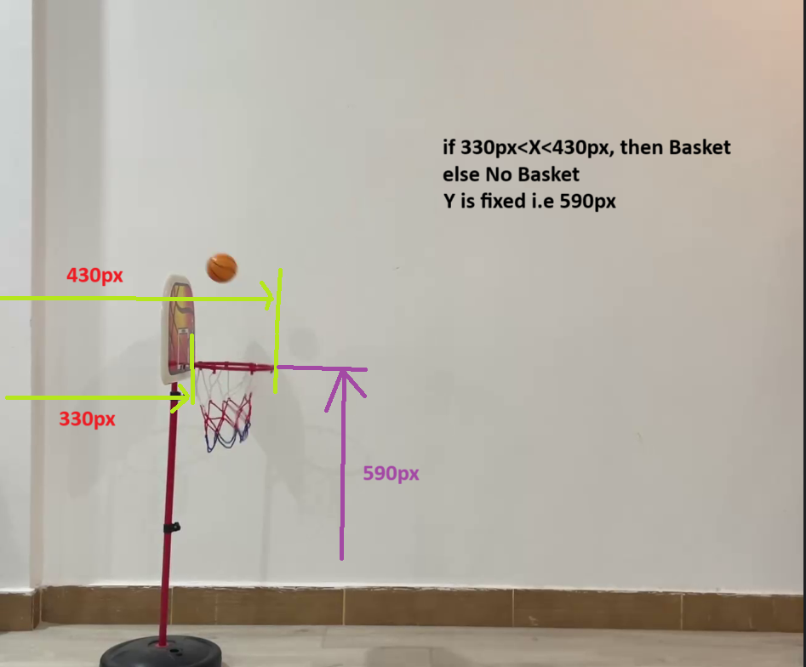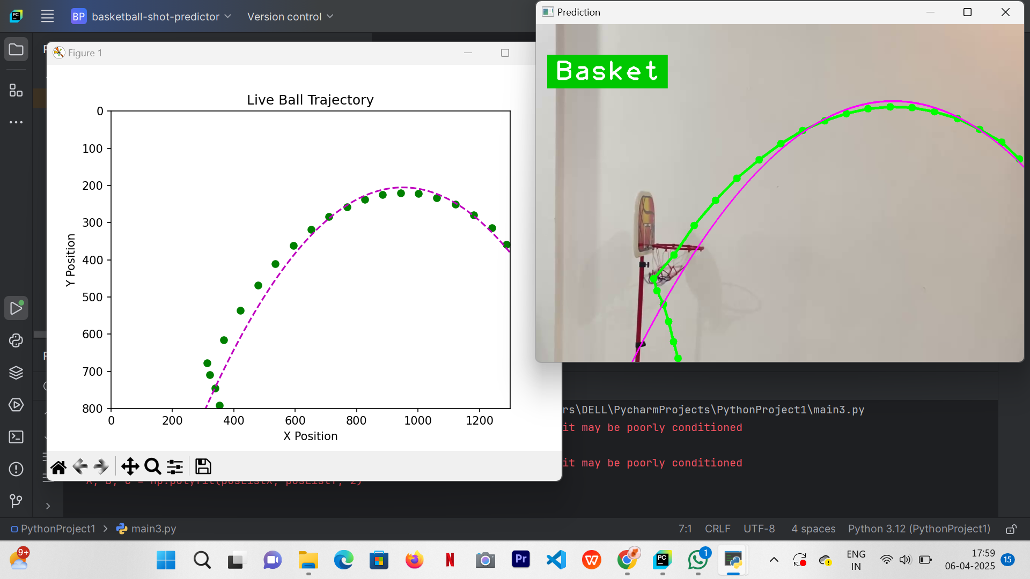

Discussion:
The proposed system, "Basketball Shot Prediction Using Polynomial Regression", is developed to analyze basketball shots using computer vision techniques and predict whether a ball will make it into the basket. The system processes video input, detects the ball using color filtering, and tracks its motion frame-by-frame. A polynomial regression model is applied to the ball’s trajectory data to predict its landing position.
Unlike traditional systems that rely on deep learning with heavy computational loads, this system is lightweight and interpretable. It provides real-time feedback, which can be extremely valuable in sports analytics and coaching scenarios. The output interface visually overlays the predicted path and result (Basket or No Basket) on the video, giving users a clear understanding of the prediction.
This innovative approach bridges sports and AI, enhancing the decision-making process for players and coaches alike. It also opens doors for further development, such as integrating force estimation or using hardware sensors for real-world implementations.
References:
- OpenCV Documentation – https://docs.opencv.org/4.x/
- Numpy Polynomial Fitting - https://numpy.org/doc/stable/reference/generated/numpy.polyfit.html
- OpenCV Color Detection Tutorial - https://docs.opencv.org/4.x/df/d9d/tutorial_py_colorspaces.html
- Advanced Computer Vision Applications in Sports - https://www.analyticsvidhya.com/blog/2021/05/advanced-computer-vision-applications-in-sports/
- Khan Academy-Projectile Motion Review - https://www.khanacademy.org/science/physics/2d-motion/projectile-motion/a/projectile-motion-review

